**ASSIGNMENT 2**

|  |  |
| --- | --- |
| Assignment Date | 06 November 2022 |
| Student Name | P.Aswini |
| Student Roll Number | 715319106004 |
| Maximum Marks | 2 Marks |

**Question-1. Import required library**

**Solution:**

import pandas as pd

import numpy as np

import matplotlib.pyplot as plt

from sklearn.model_selection import train_test_split

from sklearn.preprocessing import LabelEncoder

from keras.models import Model

from keras.layersimport LSTM,Activation, Dense, Dropout, Input, Embedding

from keras.optimizers import Adam

fromkeras.preprocessing.textimportTokenizer

from keras.preprocessing import sequence

from keras.utils import pad_sequences

from keras.utils import to_categorical

from keras.callbacks import EarlyStopping

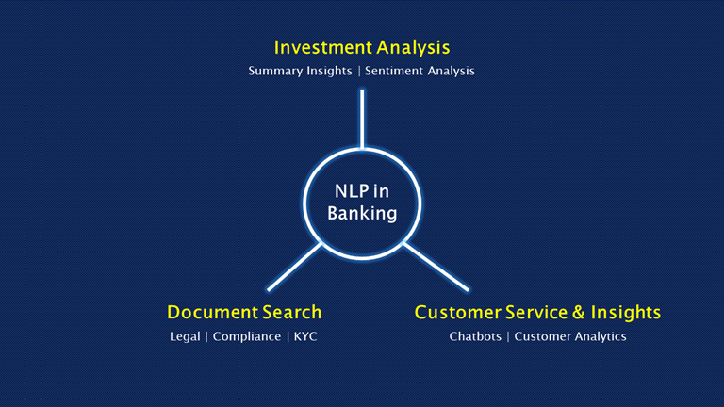

**Question-2. Read the Dataset**

**Solution:**

df = pd.read_csv('spam.csv',delimiter=',',encoding='latin-1')

df.head()

**Question-3. Preprocessing the Dataset**

**Solution:**

df.drop(['Unnamed: 2', 'Unnamed: 3', 'Unnamed: 4'],axis=1,inplace=True)

from wordcloud import WordCloud, STOPWORDS, ImageColorGenerator

X = df.v2

Y = df.v

1 le =LabelEncoder()

Y =le.fit_transform(Y)

Y = Y.reshape(-1,1)

X_train,X_test,Y_train,Y_test = train_test_split(X,Y,test_size=0.25)

max_words = 1000

max_len = 150

tok = Tokenizer(num_word s=max _ tok.fit_on_texts(X_tr

ain) words) sequences = tok.texts_to_sequences(X_train)

sequences_matrix = pad_sequenc es

(sequences,maxlen=max_len)

**Question :4**

**Solution:**

inputs = Input(shape=[max_len])

layer = Embedding(max_words,50,input_length=max_len)(inputs)

layer = LSTM(128)(layer)

layer = Dense(128)(layer)

layer = Activation('relu')(layer)

layer = Dropout(0.5)(layer)

layer = Dense(1)(layer)

layer = Activation('sigmoid')(layer)

model = Model(inputs=inputs,outputs=layer)

**Question-7. Fit the Model**

**Solution:**

history = model.fit(sequences_matrix,Y_train,batch_size=20,epochs=15,

validation_split=0.2)

metrics = pd.DataFrame(history.history)

metrics.rename(columns ={'loss':'Training_Loss', 'accuracy':'Training_Accuracy', 'val_loss': 'Valida

tion_Loss', 'val_accuracy': 'Validation_Accuracy'}, inplace = True)

def plot_graphs1(var1, var2, string):

metrics[[var1, var2]].plot()

plt.title('Training and Validation ' + string)

plt.xlabel ('Number of epochs')

plt.ylabel(string)

plt.legend([var1, var2])

plot_graphs1('Training_Accuracy', 'Validation_Accuracy', 'Accuracy')

**Question-8.Save The Model**

**Solution:**

model.save('Spam_sms_classifier.h5')

**Question-9**. **Test The Model**

**Solution:**

test_sequences = tok.texts_to_sequences(X_test)

test_sequences_matrix = pad_sequences(test_sequences,maxlen=max_len)

accuracy1 = model.evaluate(test_sequences_matrix,Y_test)